## Horse Anatomy: The Hoof

## -----------------------------------------------------------------------------------------------------------------------------------------------------------

## by Assistant Professor, Dr. Mohammed Abbas/Ph.D. Anatomy, Histology and Embryology/ Veterinary Collage, University of Basra.

## The Hoof

## Ahorse's hoof is composed of the wall, sole and frog. The wall is simply that part of the hoof that is visible when the horse is standing. It covers the front and sides of the third phalanx, or coffin joint. The wall is made up of the toe (front), quarters (sides) and heel.

The hoof wall is composed of three vaguely distinct layers: the outermost stratum externum, the stratum medium, and the innermost stratum internum. The stratum externum and stratum medium are produced by the epithelium of the coronary band, whereas the stratum internum is produced by the laminar epidermis.

**White line**

The white line is the junction of the wall and the sole.

**Sole**

The sole makes up most of the undersurface of the hoof. It is made up of nearly 33% water, so it is softer than the wall. The structure of the sole is similar to that of the wall, except that it breaks away when it grows to a certain thickness.

**Bars**

The bars are the parts of the wall that have turned inward from the heels to surround the frog. Their function is to bear weight.

**Frog**

The frog is wedge-shaped and made of rubbery and highly elastic material that is 50% moisture. The frog is a shock absorber.

**Coronary band**

The coronary band is the primary source of growth and nutrition for most of the hoof wall.

**Laminar corium (sensitive laminae)**

The laminar corium consists of laminae engorged with blood vessels. The sensitive laminae mesh with the insensitive laminae of the wall on one side, and are firmly attached to the pedal bone on the other side.

**Bones of the hoof**

Two bones are completely within the hoof. The pedal bone (also known as the distal phalanx, P3 or coffin bone) is the largest and is shaped like the hoof. The significantly smaller, shuttle-shaped navicular bone lies adjacent to the pedal bone and closer to the heel.

The hoof is a complex grouping of sensitive and insensitive structures, all of which must be kept healthy and undamaged if the horse is to stay sound. Good nutritional management and regular farrier care will help to ensure strong hooves.

## Diagram of the underside of a horse's hoof.Hooves are hard coverings that protect the toes of many animals. Hooves are not feet. They are more like toenails. Hooves allow animals to walk for long distances on hard surfaces without damaging their toes. Horses, cattle, deer, pigs, sheep, camels, and other animals have hooves.

## A horse hoof is the lower extremity of each leg of a horse, the part that makes contact with the ground and carries the weight of the animal. It is both hard and flexible. It is a complex structure surrounding

## A diagram of the bottom of a horse's hooves with labeled structures.A diagram of the internal structures of a horses hoof and lower leg.

## the distal [phalanx](https://en.wikipedia.org/wiki/Phalanx_bones) of the 3rd digit (digit III of the basic [pentadactyl limb](https://en.wikipedia.org/wiki/Pentadactyl_limb) of [vertebrates](https://en.wikipedia.org/wiki/Vertebrate), evolved into a single weight-bearing digit in horses) of each of the four limbs, which is covered by soft tissue and [keratinised](https://en.wikipedia.org/wiki/Keratin) (cornified) matter.

### The hoof is made up of two parts. The outer part, called the hoof capsule, is composed of various cornified specialized structures. The inner, living part of the hoof, is made up of soft tissues and bone. The cornified material of the hoof capsule differ in structure and properties. Dorsally, it covers, protects, and supports P3 (also known as the [coffin bone](https://en.wikipedia.org/wiki/Coffin_bone).

### Ahorse's hoof is composed of the wall, sole and frog. The wall is simply that part of the hoof that is visible when the horse is standing. It covers the front and sides of the third phalanx, or coffin bone. The wall is made up of the toe (front), quarters (sides) and heel.

**Inner Wall**

The inner hoof wall is usually white (unlike the outer wall, it does not contain pigment). It is more pliable than the outer wall due to it having a higher moisture. content which enables the inner wall to stretch more as the outer wall moves, ensuring the inner workings of the hoof are protected from too much shock as well as allowing the pedal bone and the outer wall to move in different ways without losing strength of attachment.

**Outer Wall**

The outer hoof wall is pigmented and is much stronger than the inner wall. Its purpose is to bear the weight of the horse, protect the internal structures from harm and to act like a spring, storing and releasing energy during the different phases of the stride to help propel the horse along. A healthy outer wall will be slightly thicker at the toe and have no growth rings or cracks.   It will be almost impermeable, meaning water or any other things which come in contact with it will not be able to penetrate the wall. If, however, an outer wall is damaged – either through injury or nutritional imbalance, substances which come into contact with it will seep through.

**Bar**

The bar is an extension of the hoof wall which runs along the side of the frog, terminating approximately half way along the frog. Its primary purpose is to control the movement of the back of the hoof, adding strength to the heel area and protecting it from excess distortion. It should have a high ratio of pliable inner wall to ensure it can move correctly as the heel moves. More recent research has found that the bar also produces some of the material that makes up the sole.

**Collateral Groove**

This is the groove that runs along either side of the frog. The outer wall of the groove is made up of the wall of the bar and sole and the wall on the other side comprises the wall of the frog.

Internal structures:-

There are two and a bit bones inside the hoof. The Pedal bone, the Navicular bone and the bottom part of the Short Pastern bone.

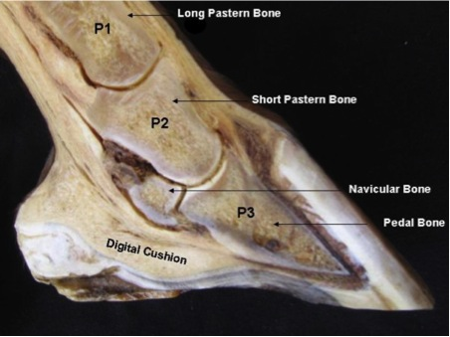

**Pedal Bone**

The large bone inside the hoof capsule is known as the Pedal bone or Coffin bone.   Its shape provides a framework for the shape of the hoof capsule it self.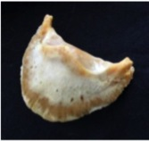

The Pedal bone provides strength and stability to the hoof and acts as a framework to hold other structures in place. It does not have a medulla (bone marrow) and has an unusually high density of tiny blood vessels running through it. Surrounding the wall of the bone is the laminae which hold the wall to the bone and produce some of the intertubular horn of the hoof wall. Underneath, the bone is covered in solar corium which produces the sole. At the back, the bone attaches to cartilage which forms a large portion of the back of the hoof . Tendons and ligaments are attached to this bone and a dense network of blood vessels run around and through it.

Navicular bone

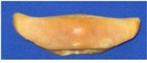This is another bone which is hard to visualise when viewed in cross section.

//////////////////////////////////////////////////////////////////////////////////////////////////////////////////////

With Best Wishes